12/7/2025

Update: Add scores for attacking the center and near-center squares

Current model: Using alpha-beta pruning to evaluate the position with max depth = 5, searching time around 5s.

Evaluate the board using materials, mobility of the pieces, and the possession of the center

Note on performance: Good at tactics, but not good enough at designing a strategy to win the game. The bot is still confused about how to win the game, although it has more materials.

An example game: Bot (White) against Chess.com bot Sven (1100) (Black)

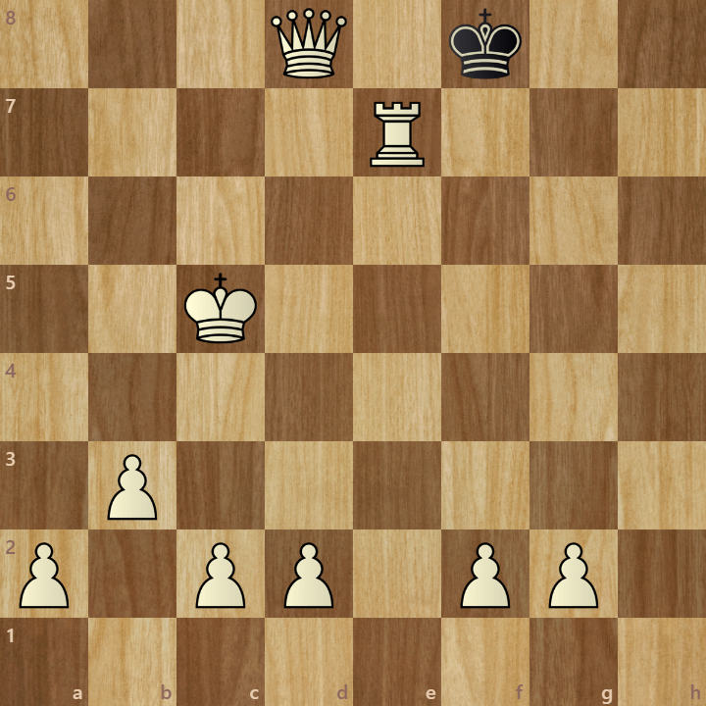

[Result "1-0"]

1. e3 e5 2. Qg4 c5 3. Nc3 Nf6 {Can you break through my fortress $2} 4. Qg5 {Are

you trying to break through my fortress $2} 4... a5 5. Qxe5+ {I don't mind

captures, as long as I can still defend.} 5... Qe7 6. Nf3 Qxe5 {You don't need

that anymore.} 7. Nxe5 {I can defend without my queen.} 7... d6 8. Bb5+ {Check $2

That's ok, I'll just defend $1} 8... Ke7 9. Nd3 Be6 10. h4 Bg4 11. b3 Bd7 12. Ba3

Bxb5 13. Nxb5 Ra6 14. Bb2 Ke8 15. Nc7+ Kd7 16. Nxa6 Nxa6 17. Bxf6 gxf6 18. Ke2

{It looks like my positional style hasn't paid off in this game $1} 18... b6 19.

h5 Ke7 20. Rh4 Ke6 21. Re4+ Kd7 22. Rf4 Nb4 23. Nxb4 cxb4 24. Rxf6 Be7 25. Rxf7

Rc8 26. Kd3 Rd8 27. Rxh7 Rc8 28. Rg7 Ke6 29. Rg6+ Kf5 30. Rh1 Re8 31. e4+ Kf4

32. Re6 d5 33. exd5 Kf5 34. h6 Rh8 35. Rxe7 Rc8 36. h7 Rh8 37. Kd4 b5 38. Re5+

Kg6 39. Kc5 Kg7 40. Kxb5 Rb8+ {I only attack if it works.} 41. Kxa5 Ra8+ 42.

Kxb4 Rd8 43. h8=Q+ {Hmm, how will I defend against this new queen.} 43... Rxh8

44. Rxh8 Kxh8 45. Re7 Kg8 46. d6 {You have broken through my fortress $1} 46...

Kf8 47. Kc5 Kg8 48. d7 Kf8 49. d8=Q# {Hmmm. You know something I don't. Can I

have a rematch $2} 1-0

13/7/2025

Update: Encourage the bot to develop pieces by subtracting scores if rooks, bishops, or knights stay in the 1st rank for White and 8th rank for Black

Current model: Using alpha-beta pruning to evaluate the position with max depth = 5, searching time around 5s.

Evaluate the board using materials, mobility of the pieces, the possession of the center, and the development of pieces.

Note on performance: Good at tactics, but not good enough at designing a strategy to win the game. The bot is still confused about how to win the game, although it has more materials. Although it knows how to develop light pieces, it still moves the queen early. I may fix this by adding scores for leaving the queen to stay at its starting pieces later.

An example game: Bot (White) against Chess.com bot Nelson (1300) (Black)

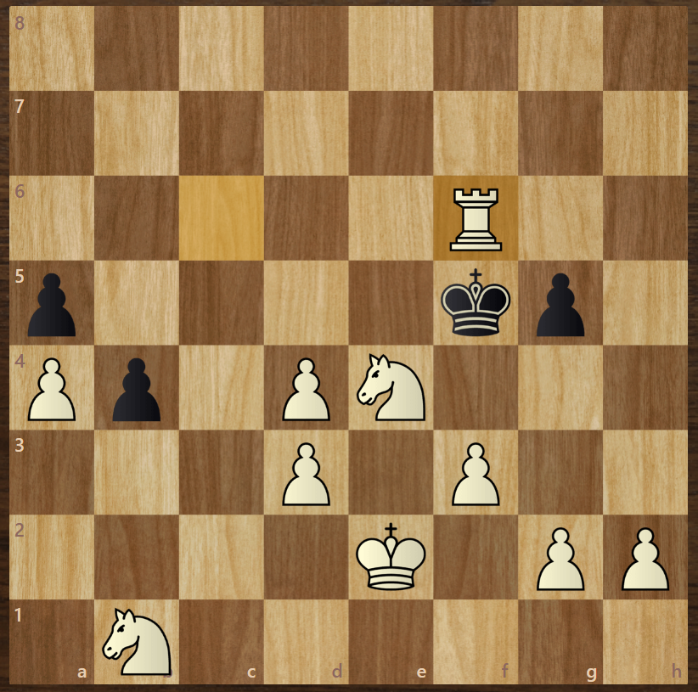

[Result "1-0"]

1. e3 e5 {Don't you just love queens $2} 2. Qg4 h5 {I'm coming at you $1} 3. Qc4 b5

4. Qd5 {What do you think you're doing $2} 4... c6 5. Qxe5+ {There goes a piece.}

5... Qe7 6. Nf3 d6 7. Qxe7+ {Oh. Maybe that's why I wasn't supposed to bring my

queen out.} 7... Bxe7 {For me $2 You shouldn't have.} 8. Bd3 a5 9. a4 b4 10. b3

Ba6 11. Bb2 Bxd3 12. cxd3 Bf6 13. Bxf6 Nxf6 14. Ke2 Nh7 15. Rc1 Ra7 16. Nd4 Nd7

17. Rxc6 {How did you avoid my early queen attacks $2 What am I going to do $2}

17... Ng5 18. Rc8+ {Oof $1 Better get the king safe.} 18... Ke7 19. Rxh8 Ne6 20.

Nc6+ Kf6 21. Nxa7 Nec5 22. Rxh5 Nxb3 23. Nc8 g6 24. Rd5 Nxa1 25. Rxd6+ Kg7 26.

Rxd7 Nb3 27. Rc7 Kh6 28. Nd6 f6 29. d4 Kg5 30. Ne4+ Kf5 31. d3 Kg4 32. f3+ {I'm

starting to get a bit worried about this one.} 32... Kf5 33. Rc6 Nxd4+ {Look

out $1} 34. exd4 g5 35. Rxf6# {How did you defend that and come out ahead $6 Can I

get a rematch $2} 1-0